**Mobile Application Development (3170726)**



**VVP**

**Engineering**

**College**

Submitted by: **DISHEN MAKWANA**

**180470107035**

**G2**

 **V. V. P. Engineering College, Rajkot**

**Department of Computer Engineering**

**Vision of the** **Institute**

* To be an exemplary institute, transforming students into competent

professionals with human values.

**Mission of the Institute**

* To provide a conducive academic environment for strengthening technical capabilities of the students.
* To strengthen linkage with industries, alumni and professional bodies.
* To organize various co-curricular and extra-curricular activities for overall development of the students.
* To practice good governance and conduct value- based activities for making students responsible citizens.

**Vision of the Department**

* Transforming students into globally efficient professionals with moral values.

**Mission of the Department**

* To provide a strong foundation of computer engineering through effective teaching learning process.
* To enhance industry linkage & alumni network for better placement and real-world exposure.
* To provide various opportunities & platforms for all round development of students & encourage them for value-based practices.

**Program Educational Objectives (PEOs)**

Graduates will be able to

* Apply computer engineering theories, principles and skills to meet the challenges of the society.
* Communicate effectively, work collaboratively and manifest professionalism with ethics.
* Exhibit life-long learning attitude and adapt to rapid technological changes in industry.
* Advance their career in industry, pursue higher education or become an entrepreneur.

## V.V.P. ENGINEERING COLLEGE

**RAJKOT**

**Certificate**

This is to certify that

Mr. DISHEN MAKWANA, Enrollment No: 180470107035, Branch: Computer Engineering, Semester: 7 has satisfactorily completed the course in the subject: **Mobile Application Development (3170726)** within the four walls of V.V.P. Engineering College, Rajkot.

Date of Submission:

**Prof. Nivid Limbasiya**, Head of Department,

Staff In-Charge Department of Computer Engineering,

V.V.P. Engineering College

**V. V. P. Engineering College**

**Department of Computer Engineering**

**Course Outcomes**

Semester: 7th

Subject: Mobile Application Development

Code: 3170726

After learning the course, the students will be able to

|  |  |
| --- | --- |
| **Sr.**  **No.** | **CO statement** |
| CO-1 | Understand Android architecture, activities and their life cycle. |
| CO-2 | Apply the knowledge to design user interface using Android UI And Component |
| CO-3 | Manage system database, remote database operations using web services and Firebase |
| CO-4 | Apply knowledge of map, location services, Graphics, android system and background services |
| CO-5 | Publish and distribute Android Application |

**Index**

|  |  |  |  |
| --- | --- | --- | --- |
| **Sr.**  **No.** | **Question/Task** | **Page** | **Sign** |
| 1. | Explain the Android Architecture. | 6 |  |
| 2. | Implement Dialog Message project | 8 |  |
| 3. | Implement Activity lifecycle and fragment life cycle project | 10 |  |
| 4 | Implement checkbox project | 15 |  |
| 5 | Implement edit-text project | 18 |  |
| 6 | Implement Grid-view project | 20 |  |
| 7 | Implement Image-view project | 24 |  |
| 8 | Implement Intent project | 26 |  |
| 9 | Implement List-view project | 28 |  |
| 10 | Implement radio button project | 30 |  |
| 11 | Implement Recycler-view project | 34 |  |
| 12 | Implement Scroll-view project | 37 |  |
| 13 | Implement Shared-preferences project | 40 |  |
| 14 | Implement Spinner Project | 42 |  |
| 15 | Implement text-view button project | 44 |  |
| 16 | Implement todo list project | 46 |  |
| 17 | Implement toggle button project | 49 |  |
| 18 | Implement Unit Converter project | 52 |  |
| 19 | Implement web-view project | 55 |  |

1. **Explain the Android Architecture.**

Android architecture is a software stack of components to support mobile device needs. Android software stack contains a Linux Kernel, collection of c/cpp libraries which are exposed through an application framework services, runtime, and application.

Following are main components of android architecture those are

1. Applications

2. Android Framework

3. Android Runtime

4. Platform Libraries

5. Linux Kernel

In these components, the Linux Kernel is the main component in android to provide its operating system functions to mobile and Dalvik Virtual Machine (DVM) which is responsible for running a mobile application.

Following is the pictorial representation of android architecture with different components.

**Applications**

The top layer of the android architecture is Applications. The native and third-party applications like contacts, email, music, gallery, clock, games, etc. whatever we will build those will be installed on this layer only.

The application layer runs within the Android run time using the classes and services made available from the application framework.

**Application** **Framework**

The Application Framework provides the classes used to create Android applications. It also provides a generic abstraction for hardware access and manages the user interface and application resources. It basically provides the services through which we can create a particular class and make that class helpful for the Application creation.

The application framework includes services like telephony service, location services, notification manager, NFC service, view system, etc. which we can use for application development as per our requirements.

**Android** **Runtime**

Android Runtime environment is an important part of Android rather than an internal part and it contains components like core libraries and the Dalvik virtual machine. The Android run time is the engine that powers our applications along with the libraries and it forms the basis for the application framework.

**Dalvik** **Virtual** **Machine** (DVM) is a register-based virtual machine-like Java Virtual Machine (JVM). It is specially designed and optimized for android to ensure that a device can run multiple instances efficiently. It relies on the Linux kernel for threading and low-level memory management.

The core libraries in android runtime will enable us to implement android applications using standard JAVA programming language.

**Platform** **Libraries**

The Platform Libraries includes various C/C++ core libraries and Java-based libraries such as SSL, libc, Graphics, SQLite, Webkit, Media, Surface Manger, OpenGL, etc. to provide support for Android development.

The following are the summary details of some core android libraries available for android development.

• Media library for playing and recording audio and video formats

• The Surface manager library to provide a display management

• SGL and OpenGL Graphics libraries for 2D and 3D graphics

• SQLite is for database support and Free Type for font support

• Web-Kit for web browser support and SSL for Internet security.

**Linux** **Kernel**

Linux Kernel is a bottom layer and heart of the android architecture. It manages all the drivers such as display drivers, camera drivers, Bluetooth drivers, audio drivers, memory drivers, etc. which are mainly required for the android device during the runtime.

The Linux Kernel will provide an abstraction layer between the device hardware and the remainder of the stack. It is responsible for memory management, power management, device management, resource access, etc.

1. **Implement Dialog Message project.**

**Activity_main.xml**

<?xml version="1.0" encoding="utf-8"?>

<androidx.constraintlayout.widget.ConstraintLayout

xmlns:android="http://schemas.android.com/apk/res/android"

xmlns:tools="http://schemas.android.com/tools"

xmlns:app="http://schemas.android.com/apk/res-auto"

android:layout_width="match_parent"

android:layout_height="match_parent"

tools:context=".MainActivity">

<TextView

android:layout_width="wrap_content"

android:layout_height="wrap_content"

android:gravity="center_horizontal"

android:text="@string/press_the_back_button_of_your_phone"

android:textSize="30sp"

android:textStyle="bold"

tools:layout_editor_absoluteX="0dp"

tools:layout_editor_absoluteY="328dp" />

</androidx.constraintlayout.widget.ConstraintLayout>

**MainActivity.java**

package com.example.alertdialog;

import androidx.appcompat.app.AlertDialog;

import androidx.appcompat.app.AppCompatActivity;

import android.os.Bundle;

import android.content.DialogInterface;

public class MainActivity extends AppCompatActivity {

@Override

protected void onCreate(Bundle savedInstanceState) {

super.onCreate(savedInstanceState);

setContentView(R.layout.activity_main);

}

@Override

public void onBackPressed()

{

AlertDialog.Builder builder = new AlertDialog.Builder(MainActivity.this);

builder.setMessage("Do you want to exit ?");

builder.setTitle("Alert !");

builder.setCancelable(false);

builder.setPositiveButton("Yes", new DialogInterface.OnClickListener() {

@Override

public void onClick(DialogInterface dialog, int which)

{

finish();

}

});

builder.setNegativeButton("No", new DialogInterface.OnClickListener() {

@Override

public void onClick(DialogInterface dialog, int which)

{

dialog.cancel();

}

});

AlertDialog alertDialog = builder.create();

alertDialog.show();

}

}

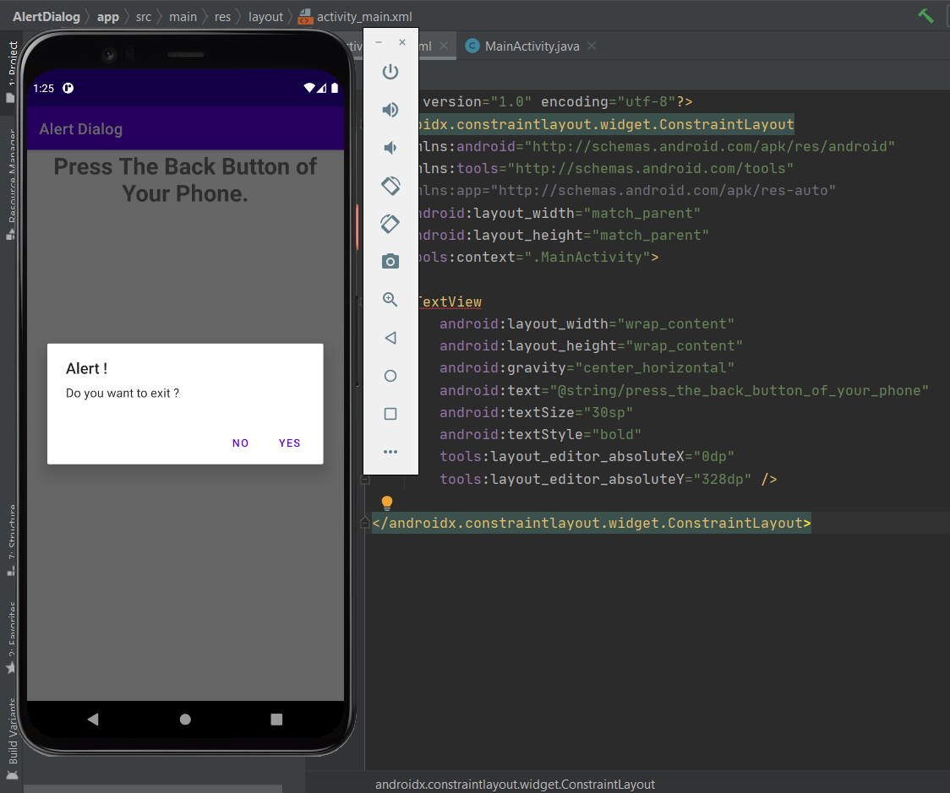

1. **Implement Activity lifecycle and fragment life cycle project.**

**MainActivity.java**

package com.example.activitylifecycle;

import androidx.appcompat.app.AppCompatActivity;

import android.os.Bundle;

import android.widget.Toast;

public class MainActivity extends AppCompatActivity {

@Override

protected void onCreate(Bundle savedInstanceState) {

super.onCreate(savedInstanceState);

setContentView(R.layout.activity_main);

Toast.makeText(getApplicationContext(), "onCreate Called", Toast.LENGTH_LONG).show();

}

protected void onStart() {

super.onStart();

Toast.makeText(getApplicationContext(), "onStart Called", Toast.LENGTH_LONG).show();

}

@Override

protected void onRestart() {

super.onRestart();

Toast.makeText(getApplicationContext(), "onRestart Called", Toast.LENGTH_LONG).show();

}

protected void onPause() {

super.onPause();

Toast.makeText(getApplicationContext(), "onPause Called", Toast.LENGTH_LONG).show();

}

protected void onResume() {

super.onResume();

Toast.makeText(getApplicationContext(), "onResume Called", Toast.LENGTH_LONG).show();

}

protected void onStop() {

super.onStop();

Toast.makeText(getApplicationContext(), "onStop Called", Toast.LENGTH_LONG).show();

}

protected void onDestroy() {

super.onDestroy();

Toast.makeText(getApplicationContext(), "onDestroy Called", Toast.LENGTH_LONG).show();

}

}

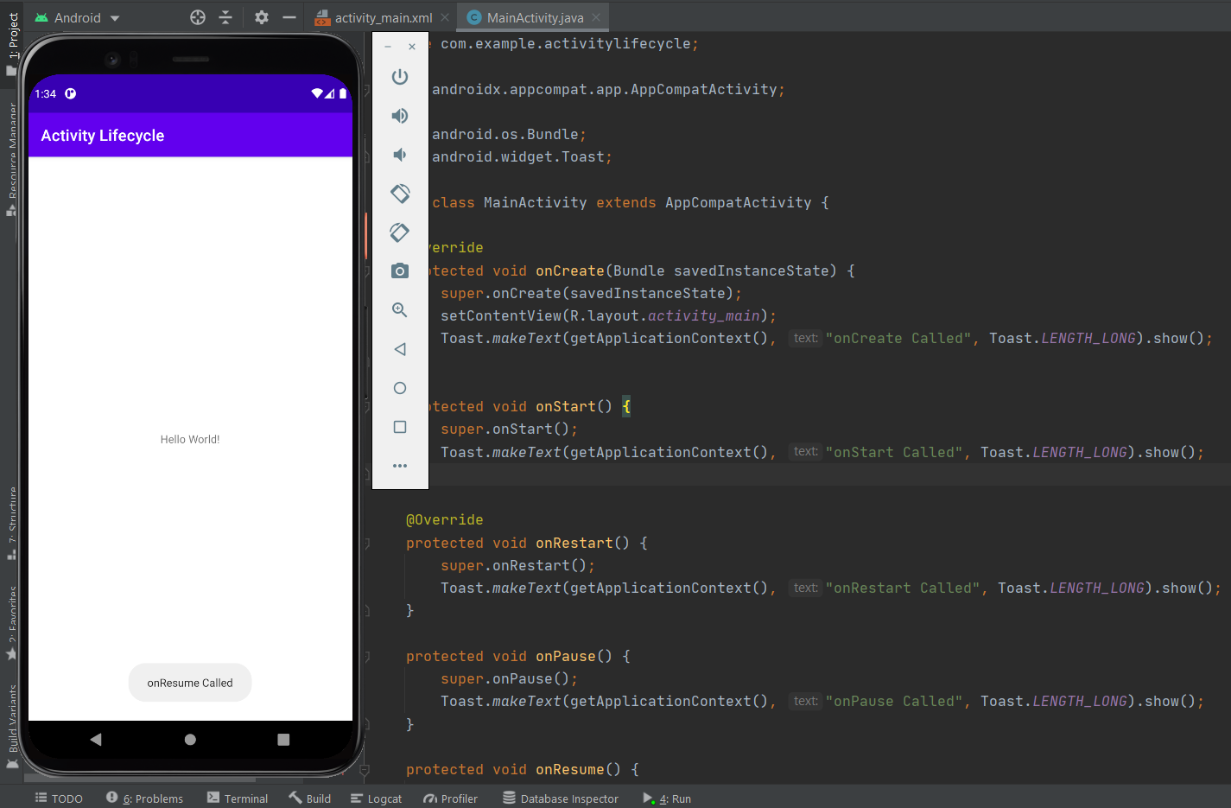

1. **Activity_main.xml**

<?xml version="1.0" encoding="utf-8"?>

<LinearLayout

xmlns:android="http://schemas.android.com/apk/res/android"

xmlns:tools="http://schemas.android.com/tools"

android:layout_width="match_parent"

android:layout_height="match_parent"

android:background="#168BC34A"

android:orientation="vertical"

tools:context=".MainActivity">

<TextView

android:id="@+id/textView"

android:layout_width="match_parent"

android:layout_height="wrap_content"

android:layout_marginTop="20dp"

android:layout_marginBottom="20dp"

android:text="@string/heading"

android:textAlignment="center"

android:textColor="@android:color/holo_green_light"

android:textSize="24sp"

android:textStyle="bold" />

<Button

android:id="@+id/button1"

android:layout_width="fill_parent"

android:layout_height="wrap_content"

android:layout_marginStart="20dp"

android:layout_marginEnd="20dp"

android:background="#4CAF50"

android:onClick="selectFragment"

android:text="@string/fragment1_button"

android:textColor="@android:color/background_light"

android:textSize="18sp"

android:textStyle="bold" />

<Button

android:id="@+id/button2"

android:layout_width="fill_parent"

android:layout_height="wrap_content"

android:layout_marginStart="20dp"

android:layout_marginTop="20dp"

android:layout_marginEnd="20dp"

android:layout_marginBottom="20dp"

android:background="#4CAF50"

android:onClick="selectFragment"

android:text="@string/fragment2_button"

android:textColor="@android:color/background_light"

android:textSize="18sp"

android:textStyle="bold" />

<fragment

android:id="@+id/fragment_section"

android:name="com.example.fragments_backup.FragmentOne"

android:layout_width="match_parent"

android:layout_height="match_parent"

android:layout_marginStart="10dp"

android:layout_marginEnd="10dp"

android:layout_marginBottom="10dp"

tools:layout="@layout/fragment_one" />

</LinearLayout>

**MainActivity.java**

package com.example.fragementlifecycle;

import androidx.appcompat.app.AppCompatActivity;

import androidx.fragment.app.Fragment;

import android.app.FragmentManager;

import android.app.FragmentTransaction;

import android.os.Bundle;

import android.view.View;

public class MainActivity extends AppCompatActivity {

@Override

protected void onCreate(Bundle savedInstanceState) {

super.onCreate(savedInstanceState);

setContentView(R.layout.activity_main);

}

public void selectFragment(View view) {

// creating object for Fragment

Fragment fr;

// displaying first fragment

// if button1 is clicked

if(view == findViewById(R.id.button1)) {

fr = new FragmentOne();

}

// displaying second fragment

// if button2 is clicked

else {

fr = new FragmentTwo();

}

FragmentManager fm = getFragmentManager();

// fragment transaction to add or replace

// fragments while activity is running

FragmentTransaction fragmentTransaction = fm.beginTransaction();

final FragmentTransaction replace = fragmentTransaction.replace(R.id.fragment_section, fr.requireParentFragment());

// making a commit after the transaction

// to assure that the change is effective

fragmentTransaction.commit();

}

}

**FragementOne.java**

package com.example.fragementlifecycle;

import android.os.Bundle;

import android.view.LayoutInflater;

import android.view.View;

import android.view.ViewGroup;

import androidx.fragment.app.Fragment;

public class FragmentOne extends Fragment {

@Override

public View onCreateView(LayoutInflater inflater, ViewGroup container, Bundle savedInstanceState) {

// inflating the layout of the fragment

// and returning the view component

return inflater.inflate(R.layout.fragment_one, container, false);

}

}

**Fragement_one.xml**

<?xml version="1.0" encoding="utf-8"?>

<LinearLayout

xmlns:android="http://schemas.android.com/apk/res/android"

android:layout_width="match_parent"

android:layout_height="match_parent"

android:background="#5C52CC57"

android:orientation="vertical">

<!-- Text to be displayed inside the Fragment -->

<TextView

android:id="@+id/textView1"

android:layout_width="match_parent"

android:layout_height="match_parent"

android:layout_weight="1"

android:gravity="center"

android:text="@string/fragment1_text1"

android:textAlignment="center"

android:textColor="@android:color/background_light"

android:textSize="24sp"

android:textStyle="bold" />

</LinearLayout>

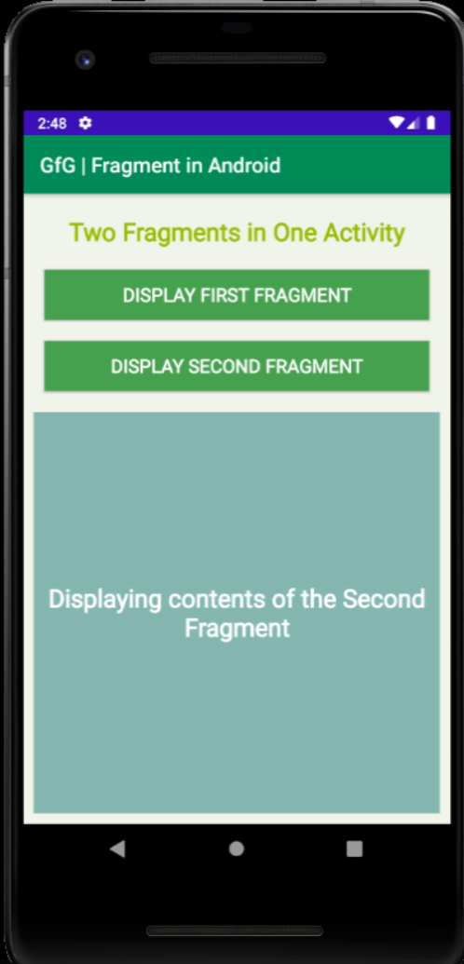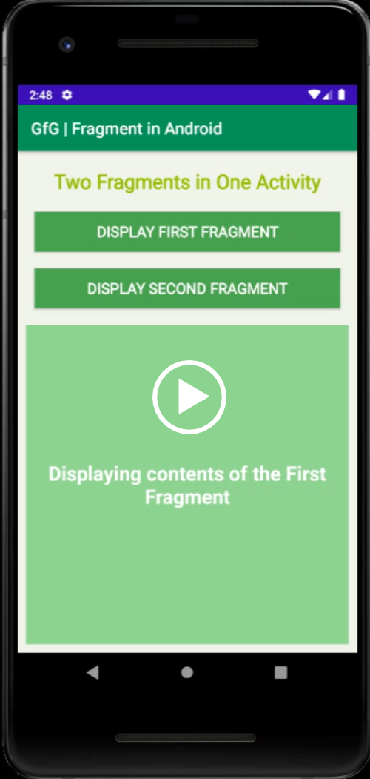

1. **Implement checkbox project.**

**MainActivity.java**

package com.example.checkbox;

import androidx.appcompat.app.AppCompatActivity;

import android.os.Bundle;

import android.view.View;

import android.widget.CheckBox;

import android.widget.TextView;

public class MainActivity extends AppCompatActivity {

TextView result;

CheckBox male;

CheckBox female;

@Override

protected void onCreate(Bundle savedInstanceState) {

super.onCreate(savedInstanceState);

setContentView(R.layout.activity_main);

result = findViewById(R.id.textViewResult);

male = findViewById(R.id.checkBoxMale);

female = findViewById(R.id.checkBoxFemale);

male.setOnClickListener(new View.OnClickListener() {

@Override

public void onClick(View v) {

if (male.isChecked())

{

result.setText("Male");

female.setChecked(false);

}

else

{

result.setText("What is your gender?");

}

}

});

female.setOnClickListener(new View.OnClickListener() {

@Override

public void onClick(View v) {

if (female.isChecked())

{

result.setText("Female");

male.setChecked(false);

}

else

{

result.setText("What is your gender?");

}

}

});

}

}

**Activity_main.xml**

<?xml version="1.0" encoding="utf-8"?>

<LinearLayout xmlns:android="http://schemas.android.com/apk/res/android"

xmlns:app="http://schemas.android.com/apk/res-auto"

xmlns:tools="http://schemas.android.com/tools"

android:layout_width="match_parent"

android:layout_height="match_parent"

android:background="@android:color/holo_blue_dark"

android:gravity="center_horizontal"

android:orientation="vertical"

tools:context=".MainActivity">

<ImageView

android:id="@+id/imageViewExample"

android:layout_width="300dp"

android:layout_height="300dp"

android:layout_marginTop="10dp"

android:scaleType="fitCenter"

app:srcCompat="@drawable/a" />

<Button

android:id="@+id/buttonOk"

android:layout_width="200dp"

android:layout_height="wrap_content"

android:layout_marginTop="30dp"

android:backgroundTint="@color/white"

android:text="OK"

android:textColor="@color/black"

android:textSize="20sp" />

<TextView

android:id="@+id/textViewResult"

android:layout_width="300dp"

android:layout_height="40dp"

android:layout_marginTop="30dp"

android:background="@color/white"

android:gravity="center_vertical"

android:text="What is your gender?"

android:textColor="@color/black"

android:textSize="20sp"

tools:layout_editor_absoluteX="335dp"

tools:layout_editor_absoluteY="583dp" />

<CheckBox

android:id="@+id/checkBoxMale"

android:layout_width="wrap_content"

android:layout_height="wrap_content"

android:layout_marginTop="10dp"

android:text="Male"

android:textColor="@color/white" />

<CheckBox

android:id="@+id/checkBoxFemale"

android:layout_width="wrap_content"

android:layout_height="wrap_content"

android:layout_marginTop="10dp"

android:text="Female"

android:textColor="@color/white" />

</LinearLayout>

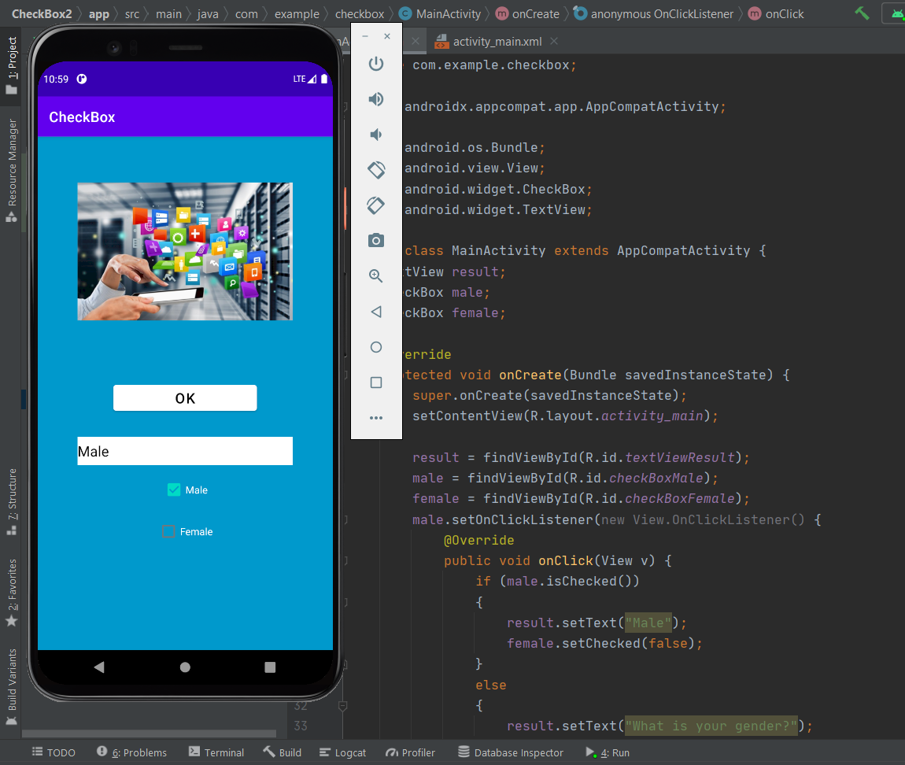

1. **Implement edit text project.**

**MainActivity.java**

package com.example.edittext;

import androidx.appcompat.app.AppCompatActivity;

import android.os.Bundle;

import android.view.View;

import android.widget.Button;

import android.widget.EditText;

import android.widget.Toast;

public class MainActivity extends AppCompatActivity {

private EditText editText;

private Button button;

@Override

protected void onCreate(Bundle savedInstanceState) {

super.onCreate(savedInstanceState);

setContentView(R.layout.activity_main);

editText

= (EditText)findViewById(R.id.edittext_id);

button

= (Button)findViewById(R.id.button_id);

button.setOnClickListener(

new View.OnClickListener() {

@Override

public void onClick(View v)

{

String name

= editText.getText()

.toString();

Toast.makeText(MainActivity.this,

"Welcome to My World "

+ name,

Toast.LENGTH_SHORT)

.show();

}

});

}

}

**Activity_main.xml**

<?xml version="1.0" encoding="utf-8"?>

<RelativeLayout

xmlns:android="http://schemas.android.com/apk/res/android"

xmlns:app="http://schemas.android.com/apk/res-auto"

xmlns:tools="http://schemas.android.com/tools"

android:layout_width="match_parent"

android:layout_height="match_parent"

tools:context=".MainActivity"

android:gravity="center">

<EditText

android:id="@+id/edittext_id"

android:layout_width="300dp"

android:layout_height="40dp"

android:hint="Enter your Name"/>

<Button

android:id="@+id/button_id"

android:layout_width="300dp"

android:layout_height="40dp"

android:layout_below="@+id/edittext_id"

android:layout_marginTop="20dp"

android:text="Submit"

android:textColor="#fff"

android:background="@color/white"/>

</RelativeLayout>

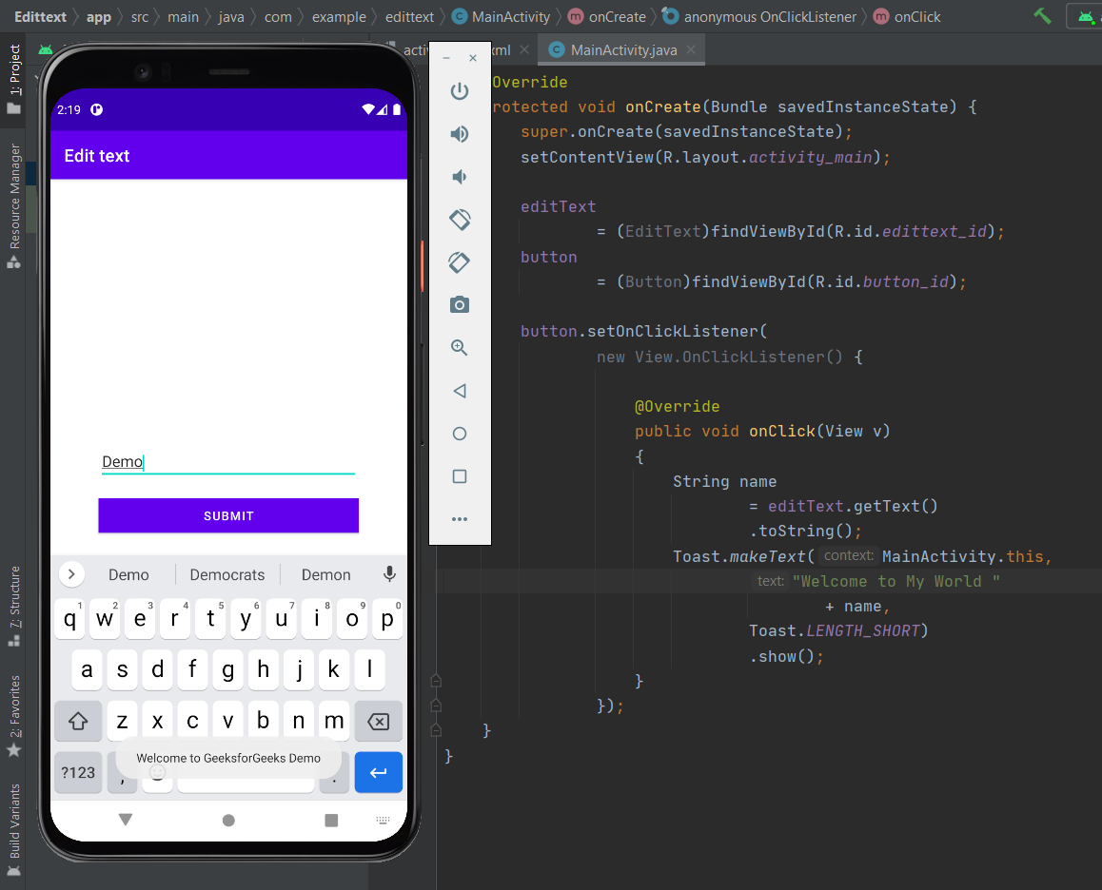

1. **Implement Grid view project.**

**MainActivity.java**

package com.example.gridview;

import androidx.appcompat.app.AppCompatActivity;

import android.os.Bundle;

import android.widget.GridView;

import java.util.ArrayList;

public class MainActivity extends AppCompatActivity {

GridView coursesGV;

@Override

protected void onCreate(Bundle savedInstanceState) {

super.onCreate(savedInstanceState);

setContentView(R.layout.activity_main);

coursesGV = findViewById(R.id.idGVcourses);

ArrayList<CourseModel> courseModelArrayList = new ArrayList<CourseModel>();

courseModelArrayList.add(new CourseModel("DSA", R.drawable.ic_gfglogo));

courseModelArrayList.add(new CourseModel("JAVA", R.drawable.ic_gfglogo));

courseModelArrayList.add(new CourseModel("C++", R.drawable.ic_gfglogo));

courseModelArrayList.add(new CourseModel("Python", R.drawable.ic_gfglogo));

courseModelArrayList.add(new CourseModel("Javascript", R.drawable.ic_gfglogo));

courseModelArrayList.add(new CourseModel("DSA", R.drawable.ic_gfglogo));

CourseGVAdapter adapter = new CourseGVAdapter(this, courseModelArrayList);

coursesGV.setAdapter(adapter);

}

}

**CourseModel.java**

package com.example.gridview;

public class CourseModel {

private String course_name;

private int imgid;

public CourseModel(String course_name, int imgid) {

this.course_name = course_name;

this.imgid = imgid;

}

public String getCourse_name() {

return course_name;

}

public void setCourse_name(String course_name) {

this.course_name = course_name;

}

public int getImgid() {

return imgid;

}

public void setImgid(int imgid) {

this.imgid = imgid;

}

}

**CourseGVAdapter.java**

package com.example.gridview;

import android.content.Context;

import android.view.LayoutInflater;

import android.view.View;

import android.view.ViewGroup;

import android.widget.ArrayAdapter;

import android.widget.ImageView;

import android.widget.TextView;

import androidx.annotation.NonNull;

import androidx.annotation.Nullable;

import java.util.ArrayList;

public class CourseGVAdapter extends ArrayAdapter<CourseModel> {

public CourseGVAdapter(@NonNull Context context, ArrayList<CourseModel> courseModelArrayList) {

super(context, 0, courseModelArrayList);

}

@NonNull

@Override

public View getView(int position, @Nullable View convertView, @NonNull ViewGroup parent) {

View listitemView = convertView;

if (listitemView == null) {

// Layout Inflater inflates each item to be displayed in GridView.

listitemView = LayoutInflater.from(getContext()).inflate(R.layout.card_item, parent, false);

}

CourseModel courseModel = getItem(position);

TextView courseTV = listitemView.findViewById(R.id.idTVCourse);

ImageView courseIV = listitemView.findViewById(R.id.idIVcourse);

courseTV.setText(courseModel.getCourse_name());

courseIV.setImageResource(courseModel.getImgid());

return listitemView;

}

}

**Card_item.xml**

<?xml version="1.0" encoding="utf-8"?>

<androidx.constraintlayout.widget.ConstraintLayout

xmlns:android="http://schemas.android.com/apk/res/android"

xmlns:app="http://schemas.android.com/apk/res-auto"

android:layout_width="match_parent"

android:layout_height="120dp"

android:layout_gravity="center"

android:layout_margin="5dp"

app:cardCornerRadius="5dp"

app:cardElevation="5dp">

<LinearLayout

android:layout_width="match_parent"

android:layout_height="wrap_content"

android:orientation="vertical">

<ImageView

android:id="@+id/idIVcourse"

android:layout_width="100dp"

android:layout_height="100dp"

android:layout_gravity="center"

android:src="@mipmap/ic_launcher" />

<TextView

android:id="@+id/idTVCourse"

android:layout_width="match_parent"

android:layout_height="wrap_content"

android:text="@string/app_name"

android:textAlignment="center" />

</LinearLayout>

</androidx.constraintlayout.widget.ConstraintLayout>

**Activity_main.xml**

<?xml version="1.0" encoding="utf-8"?>

<androidx.constraintlayout.widget.ConstraintLayout

xmlns:android="http://schemas.android.com/apk/res/android"

xmlns:tools="http://schemas.android.com/tools"

android:layout_width="match_parent"

android:layout_height="match_parent"

tools:context=".MainActivity">

<GridView

android:id="@+id/idGVcourses"

android:layout_width="match_parent"

android:layout_height="match_parent"

android:horizontalSpacing="6dp"

android:numColumns="2"

android:verticalSpacing="6dp" />

</androidx.constraintlayout.widget.ConstraintLayout>

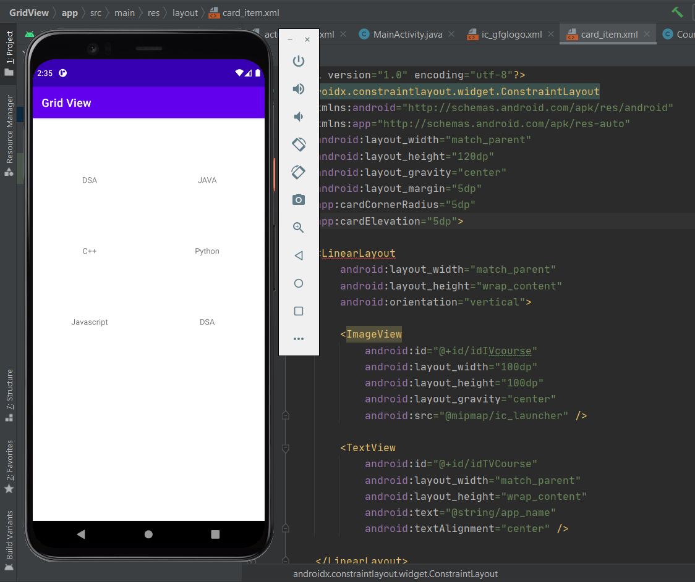

1. **Implement Image view project.**

**Activity_main.xml**

<?xml version="1.0" encoding="utf-8"?>

<androidx.constraintlayout.widget.ConstraintLayout

xmlns:android="http://schemas.android.com/apk/res/android"

xmlns:app="http://schemas.android.com/apk/res-auto"

xmlns:tools="http://schemas.android.com/tools"

android:layout_width="match_parent"

android:layout_height="match_parent"

tools:context=".MainActivity">

<ImageView

android:id="@+id/GfG_full_logo"

android:layout_width="0dp"

android:layout_height="wrap_content"

app:layout_constraintBottom_toBottomOf="parent"

app:layout_constraintEnd_toEndOf="parent"

app:layout_constraintHorizontal_bias="0.0"

app:layout_constraintStart_toStartOf="parent"

app:layout_constraintTop_toTopOf="parent"

app:layout_constraintVertical_bias="0.0"

app:srcCompat="@drawable/app" />

<ImageView

android:id="@+id/GfG_logo"

android:layout_width="wrap_content"

android:layout_height="wrap_content"

app:layout_constraintBottom_toBottomOf="parent"

app:layout_constraintEnd_toEndOf="parent"

app:layout_constraintHorizontal_bias="1.0"

app:layout_constraintStart_toStartOf="parent"

app:layout_constraintTop_toBottomOf="@+id/GfG_full_logo"

app:layout_constraintVertical_bias="1.0"

app:srcCompat="@drawable/demo" />

</androidx.constraintlayout.widget.ConstraintLayout>

**MainActivity.java**

package com.example.imageview;

import androidx.appcompat.app.AppCompatActivity;

import android.os.Bundle;

public class MainActivity extends AppCompatActivity {

@Override

protected void onCreate(Bundle savedInstanceState) {

super.onCreate(savedInstanceState);

setContentView(R.layout.activity_main);

}

}

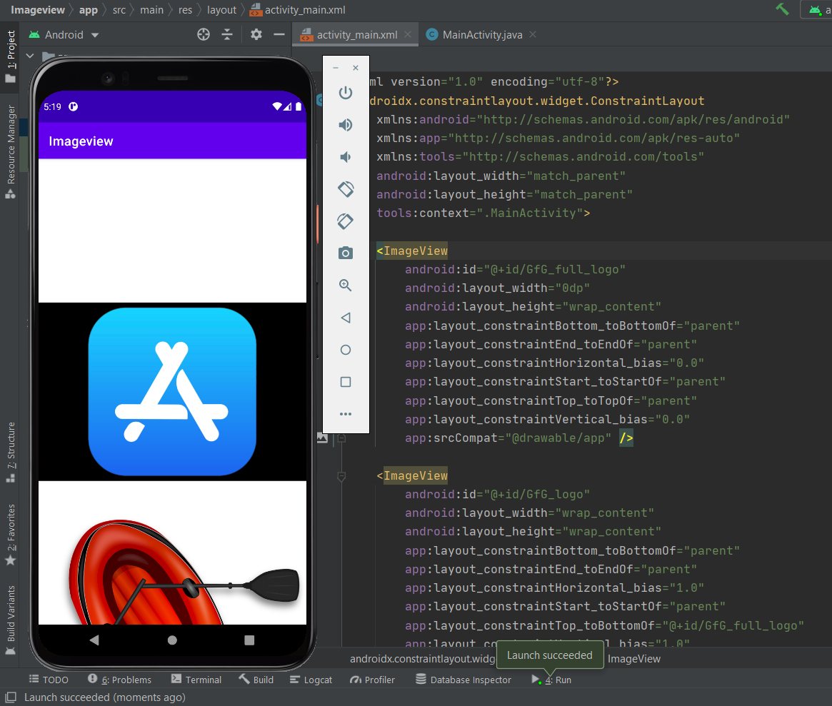

1. **Implement Intent project.**

**Activity_main.xml**

<?xml version="1.0" encoding="utf-8"?>

<androidx.constraintlayout.widget.ConstraintLayout

xmlns:android="http://schemas.android.com/apk/res/android"

xmlns:app="http://schemas.android.com/apk/res-auto"

xmlns:tools="http://schemas.android.com/tools"

android:layout_width="match_parent"

android:layout_height="match_parent"

tools:context=".MainActivity">

<EditText

android:id="@+id/editText"

android:layout_width="wrap_content"

android:layout_height="wrap_content"

android:layout_marginEnd="8dp"

android:layout_marginStart="8dp"

android:layout_marginTop="60dp"

android:ems="10"

app:layout_constraintEnd_toEndOf="parent"

app:layout_constraintHorizontal_bias="0.575"

app:layout_constraintStart_toStartOf="parent"

app:layout_constraintTop_toTopOf="parent" />

<Button

android:id="@+id/button"

android:layout_width="wrap_content"

android:layout_height="wrap_content"

android:layout_marginRight="8dp"

android:layout_marginLeft="156dp"

android:layout_marginTop="172dp"

android:text="Visit"

app:layout_constraintEnd_toEndOf="parent"

app:layout_constraintHorizontal_bias="0.0"

app:layout_constraintStart_toStartOf="parent"

app:layout_constraintTop_toBottomOf="@+id/editText" />

</androidx.constraintlayout.widget.ConstraintLayout>

**MainActivity.java**

package com.example.intent;

import androidx.appcompat.app.AppCompatActivity;

import android.content.Intent;

import android.net.Uri;

import android.os.Bundle;

import android.view.View;

import android.widget.Button;

import android.widget.EditText;

public class MainActivity extends AppCompatActivity {

Button button;

EditText editText;

@Override

protected void onCreate(Bundle savedInstanceState) {

super.onCreate(savedInstanceState);

setContentView(R.layout.activity_main);

button = findViewById(R.id.button);

editText = findViewById(R.id.editText);

button.setOnClickListener(new View.OnClickListener() {

@Override

public void onClick(View view) {

String url=editText.getText().toString();

Intent intent=new Intent(Intent.ACTION_VIEW, Uri.parse(url));

startActivity(intent);

}

});

}

}

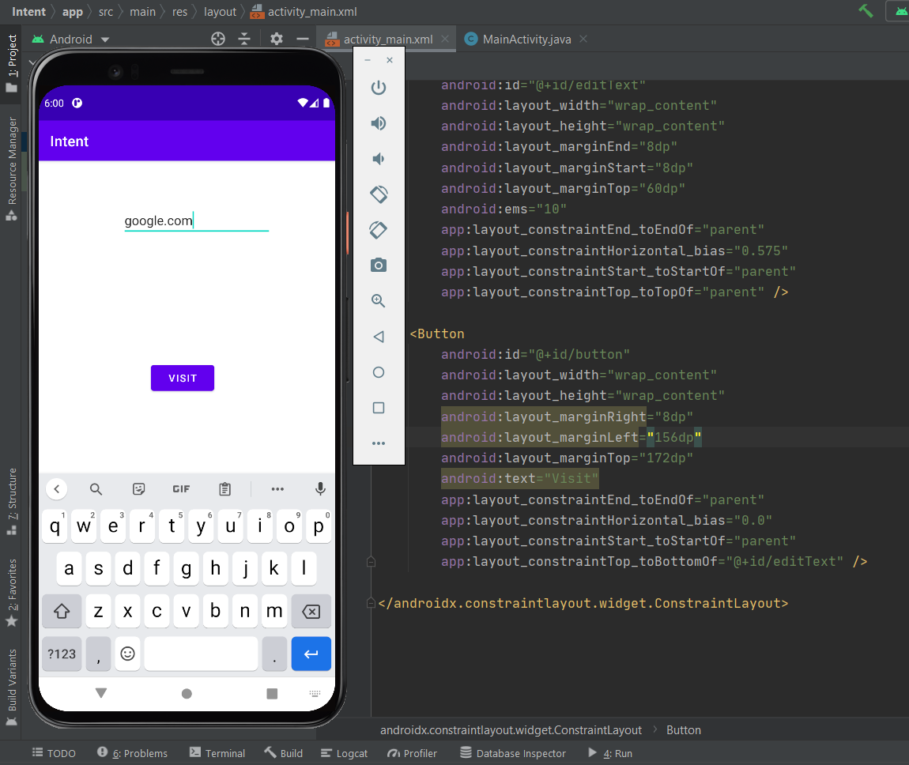

1. **Implement List view project.**

**MainActivity.java**

package com.example.listview;

import androidx.appcompat.app.AppCompatActivity;

import android.os.Bundle;

import android.widget.ArrayAdapter;

import android.widget.ListView;

public class MainActivity extends AppCompatActivity {

ListView l;

String tutorials[]

= { "Algorithms", "Data Structures",

"Languages", "Interview Corner",

"GATE", "ISRO CS",

"UGC NET CS", "CS Subjects",

"Web Technologies" };

@Override

protected void onCreate(Bundle savedInstanceState) {

super.onCreate(savedInstanceState);

setContentView(R.layout.activity_main);

l = findViewById(R.id.list);

ArrayAdapter<String> arr;

arr = new ArrayAdapter<String>(this, R.layout.support_simple_spinner_dropdown_item, tutorials);

l.setAdapter(arr);

}

}

**Activity_main.xml**

<?xml version="1.0" encoding="utf-8"?>

<LinearLayout

xmlns:android="http://schemas.android.com/apk/res/android"

xmlns:app="http://schemas.android.com/apk/res-auto"

xmlns:tools="http://schemas.android.com/tools"

android:layout_width="match_parent"

android:layout_height="match_parent"

tools:context=".MainActivity">

<ListView

android:id="@+id/list"

android:layout_width="match_parent"

android:layout_height="match_parent"/>

</LinearLayout>

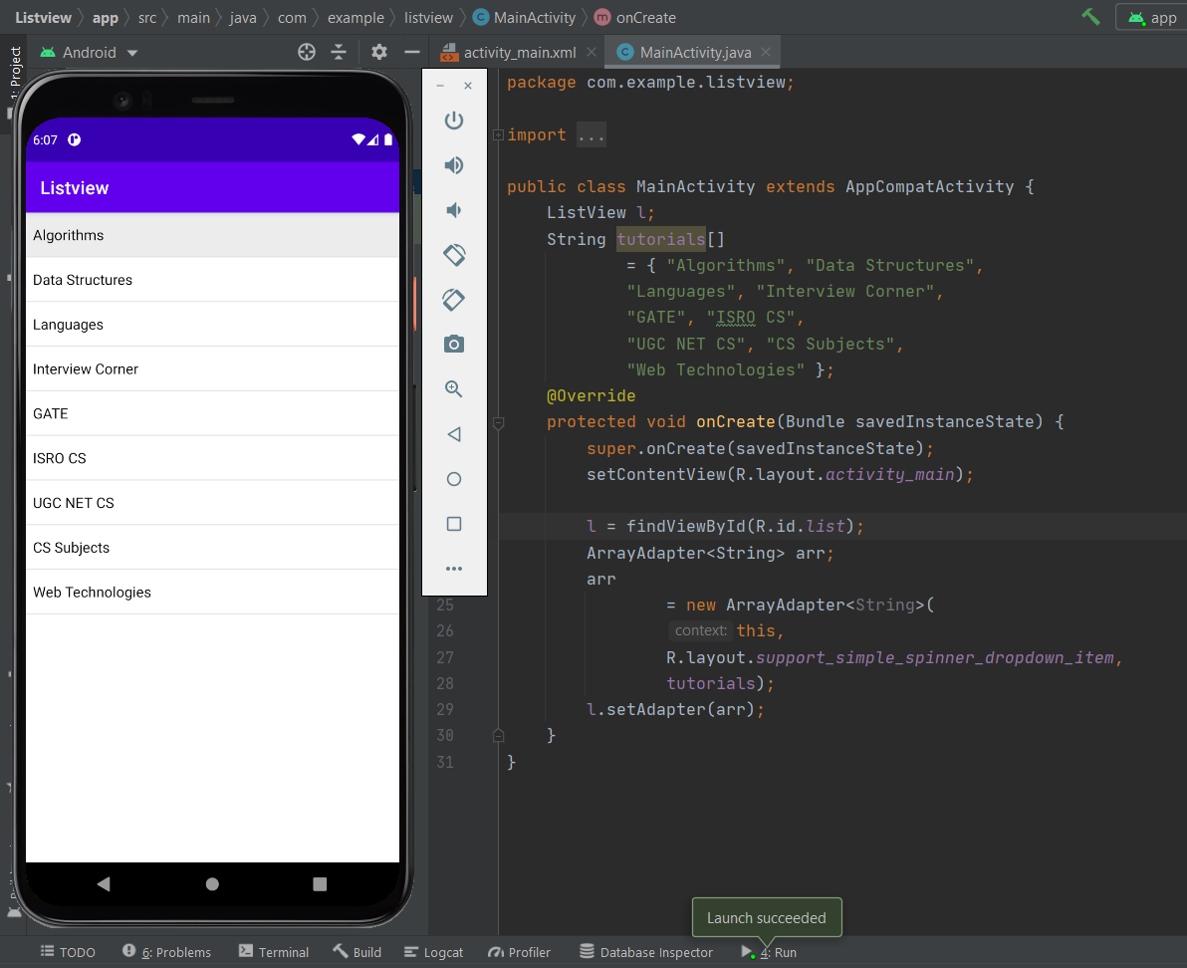

1. **Implement radio button project.**

**MainActivity.java**

package com.example.radiobutton;

import androidx.appcompat.app.AppCompatActivity;

import android.os.Bundle;

import android.view.View;

import android.widget.Button;

import android.widget.RadioButton;

import android.widget.RadioGroup;

import android.widget.Toast;

public class MainActivity extends AppCompatActivity {

private RadioGroup radioGroup;

Button submit, clear;

@Override

protected void onCreate(Bundle savedInstanceState) {

super.onCreate(savedInstanceState);

setContentView(R.layout.activity_main);

submit = (Button) findViewById(R.id.submit);

clear = (Button) findViewById(R.id.clear);

radioGroup = (RadioGroup) findViewById(R.id.groupradio);

radioGroup.clearCheck();

radioGroup.setOnCheckedChangeListener(

new RadioGroup

.OnCheckedChangeListener() {

@Override

public void onCheckedChanged(RadioGroup group, int checkedId) {

RadioButton

radioButton

= (RadioButton) group

.findViewById(checkedId);

}

});

submit.setOnClickListener(new View.OnClickListener() {

@Override

public void onClick(View v) {

int selectedId = radioGroup.getCheckedRadioButtonId();

if (selectedId == -1) {

Toast.makeText(MainActivity.this,

"No answer has been selected",

Toast.LENGTH_SHORT)

.show();

} else {

RadioButton radioButton

= (RadioButton) radioGroup

.findViewById(selectedId);

Toast.makeText(MainActivity.this,

radioButton.getText(),

Toast.LENGTH_SHORT)

.show();

}

}

});

clear.setOnClickListener(new View.OnClickListener() {

@Override

public void onClick(View v) {

radioGroup.clearCheck();

}

});

}

}

**Activity_main.xml**

<?xml version="1.0" encoding="utf-8"?>

<RelativeLayout

xmlns:android="http://schemas.android.com/apk/res/android"

xmlns:app="http://schemas.android.com/apk/res-auto"

xmlns:tools="http://schemas.android.com/tools"

android:layout_width="match_parent"

android:layout_height="match_parent"

tools:context=".MainActivity">

<TextView

android:layout_width="wrap_content"

android:layout_height="wrap_content"

android:text="Select your Subject ?"

android:textStyle="bold"

android:layout_marginLeft="10dp"

android:textSize="20dp"/>

<RadioGroup

android:layout_marginTop="50dp"

android:id="@+id/groupradio"

android:layout_marginLeft="10dp"

android:layout_width="fill_parent"

android:layout_height="wrap_content">

<RadioButton

android:layout_width="fill_parent"

android:layout_height="wrap_content"

android:id="@+id/radia_id1"

android:text="DBMS"

android:textSize="20dp"/>

<RadioButton

android:layout_width="fill_parent"

android:layout_height="wrap_content"

android:id="@+id/radia_id2"

android:text="C/C++ Programing"

android:textSize="20dp"/>

<RadioButton

android:layout_width="fill_parent"

android:layout_height="wrap_content"

android:id="@+id/radia_id3"

android:text="Data Structure"

android:textSize="20dp"/>

<RadioButton

android:layout_width="fill_parent"

android:layout_height="wrap_content"

android:id="@+id/radia_id4"

android:text="Algorithms"

android:textSize="20dp"/>

</RadioGroup>

<Button

android:layout_width="wrap_content"

android:layout_height="wrap_content"

android:text="Submit"

android:id="@+id/submit"

android:textStyle="bold"

android:textSize="20dp"

android:layout_marginTop="250dp"

android:layout_marginLeft="180dp"

/>

<Button

android:layout_width="wrap_content"

android:layout_height="wrap_content"

android:text="Clear"

android:id="@+id/clear"

android:textSize="20dp"

android:textStyle="bold"

android:layout_marginTop="250dp"

android:layout_marginLeft="20dp"

/>

</RelativeLayout>

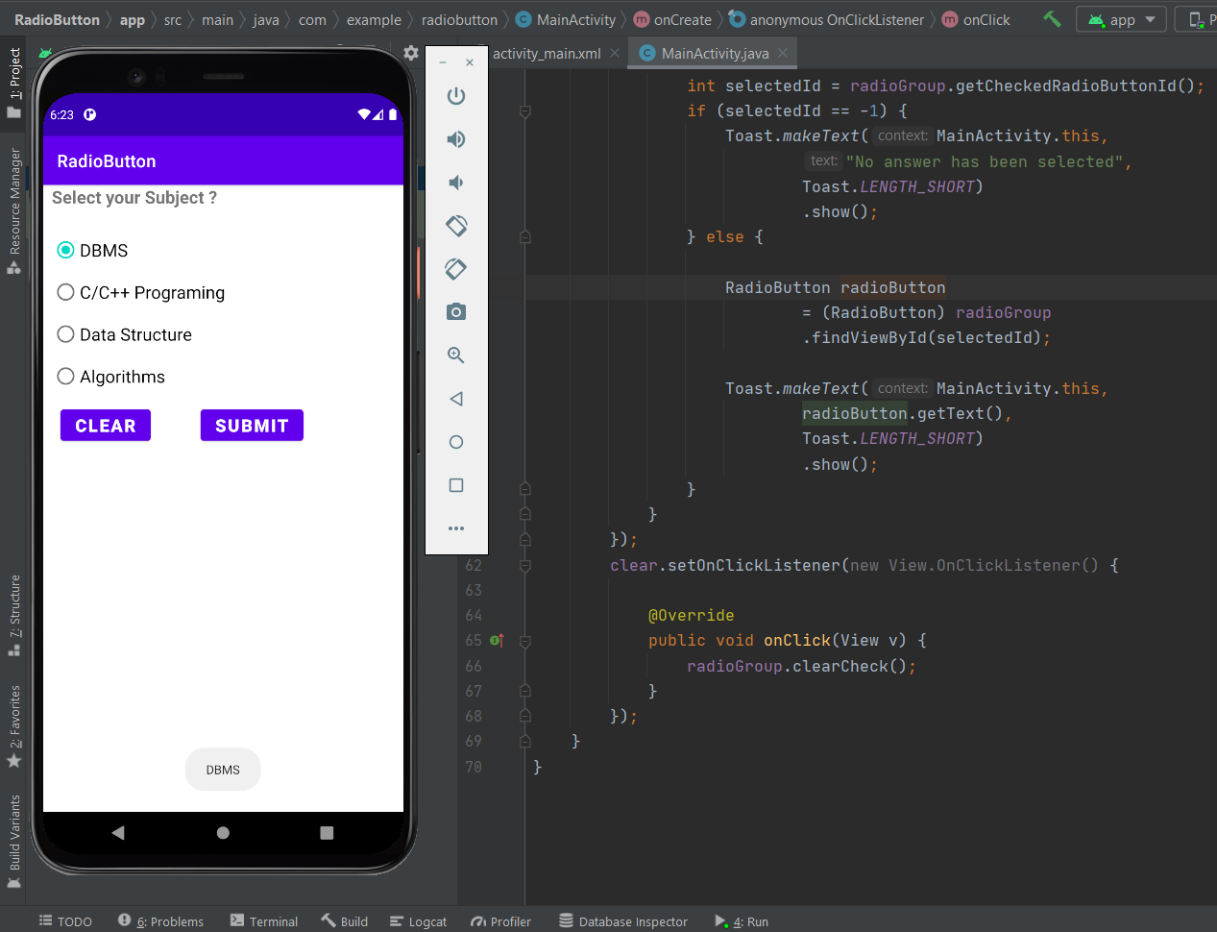

1. **Implement Recycler view project.**

**Activity_main.xml**

<?xml version="1.0" encoding="utf-8"?>

<android.support.v7.widget.RecyclerView

xmlns:android="http://schemas.android.com/apk/res/android"

xmlns:tools="http://schemas.android.com/tools"

android:layout_width="match_parent"

android:layout_height="match_parent"

android:scrollbars="vertical"

android:id="@+id/recyclerView"

tools:context="example.javatpoint.com.recyclerviewlist.MainActivity">

</android.support.v7.widget.RecyclerView>

**MainActivity.java**

package com.example.recyclerview;

import androidx.appcompat.app.AppCompatActivity;

import androidx.recyclerview.widget.LinearLayoutManager;

import androidx.recyclerview.widget.RecyclerView;

import android.os.Bundle;

public class MainActivity extends AppCompatActivity {

@Override

protected void onCreate(Bundle savedInstanceState) {

super.onCreate(savedInstanceState);

setContentView(R.layout.activity_main);

MyListData[] myListData = new MyListData[] {

new MyListData("Email", android.R.drawable.ic_dialog_email),

new MyListData("Info", android.R.drawable.ic_dialog_info),

new MyListData("Delete", android.R.drawable.ic_delete),

new MyListData("Dialer", android.R.drawable.ic_dialog_dialer),

new MyListData("Alert", android.R.drawable.ic_dialog_alert),

new MyListData("Map", android.R.drawable.ic_dialog_map),

new MyListData("Email", android.R.drawable.ic_dialog_email),

new MyListData("Info", android.R.drawable.ic_dialog_info),

new MyListData("Delete", android.R.drawable.ic_delete),

new MyListData("Dialer", android.R.drawable.ic_dialog_dialer),

new MyListData("Alert", android.R.drawable.ic_dialog_alert),

new MyListData("Map", android.R.drawable.ic_dialog_map),

};

RecyclerView recyclerView = (RecyclerView) findViewById(R.id.recyclerView);

MyListAdapter adapter = new MyListAdapter(myListData);

recyclerView.setHasFixedSize(true);

recyclerView.setLayoutManager(new LinearLayoutManager(this));

recyclerView.setAdapter(adapter);

}

}

**MyListAdapter.java**

package com.example.recyclerview;

import android.view.LayoutInflater;

import android.view.View;

import android.view.ViewGroup;

import android.widget.ImageView;

import android.widget.RelativeLayout;

import android.widget.TextView;

import android.widget.Toast;

import androidx.recyclerview.widget.RecyclerView;

public class MyListAdapter extends RecyclerView.Adapter<MyListAdapter.ViewHolder>

{

private MyListData[] listdata;

// RecyclerView recyclerView;

public MyListAdapter(MyListData[] listdata) {

this.listdata = listdata;

}

@Override

public ViewHolder onCreateViewHolder(ViewGroup parent, int viewType) {

LayoutInflater layoutInflater = LayoutInflater.from(parent.getContext());

View listItem= layoutInflater.inflate(R.layout.list_item, parent, false);

ViewHolder viewHolder = new ViewHolder(listItem);

return viewHolder;

}

@Override

public void onBindViewHolder(ViewHolder holder, int position) {

final MyListData myListData = listdata[position];

holder.textView.setText(listdata[position].getDescription());

holder.imageView.setImageResource(listdata[position].getImgId());

holder.relativeLayout.setOnClickListener(new View.OnClickListener() {

@Override

public void onClick(View view) {

Toast.makeText(view.getContext(),"click on item: "+myListData.getDescription(),Toast.LENGTH_LONG).show();

}

});

}

@Override

public int getItemCount() {

return listdata.length;

}

public static class ViewHolder extends RecyclerView.ViewHolder {

public ImageView imageView;

public TextView textView;

public RelativeLayout relativeLayout;

public ViewHolder(View itemView) {

super(itemView);

this.imageView = (ImageView) itemView.findViewById(R.id.imageView);

this.textView = (TextView) itemView.findViewById(R.id.textView);

relativeLayout = (RelativeLayout)itemView.findViewById(R.id.relativeLayout);

}

}

}

**List_item.xml**

<?xml version="1.0" encoding="utf-8"?>

<RelativeLayout xmlns:android="http://schemas.android.com/apk/res/android"

android:id="@+id/relativeLayout"

android:layout_width="match_parent"

android:layout_height="?android:attr/listPreferredItemHeightLarge"

android:background="@drawable/border">

<ImageView

android:id="@+id/imageView"

android:layout_width="wrap_content"

android:layout_height="wrap_content"

android:layout_centerVertical="true"

android:layout_alignParentStart="true"

android:layout_alignParentLeft="true"

android:layout_marginStart="@dimen/activity_horizontal_margin"

android:layout_marginEnd="@dimen/activity_horizontal_margin"

android:contentDescription="Icon" />

<TextView

android:id="@+id/textView"

android:layout_width="wrap_content"

android:layout_height="match_parent"

android:layout_toEndOf="@id/imageView"

android:layout_toRightOf="@id/imageView"

android:gravity="center_vertical"

android:textSize="16sp"/>

</RelativeLayout>

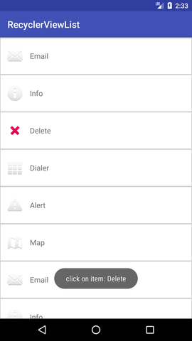

1. **Implement Scroll view project.**

**Activity_main.xml**

<?xml version="1.0" encoding="utf-8"?>

<RelativeLayout xmlns:android="http://schemas.android.com/apk/res/android"

xmlns:tools="http://schemas.android.com/tools"

android:layout_width="match_parent"

android:layout_height="match_parent"

android:paddingBottom="@dimen/activity_vertical_margin"

android:paddingLeft="@dimen/activity_horizontal_margin"

android:paddingRight="@dimen/activity_horizontal_margin"

android:paddingTop="@dimen/activity_vertical_margin"

tools:context="com.example.test.scrollviews.MainActivity">

<TextView

android:layout_width="wrap_content"

android:layout_height="wrap_content"

android:textAppearance="?android:attr/textAppearanceMedium"

android:text="Vertical ScrollView example"

android:id="@+id/textView"

android:layout_gravity="center_horizontal"

android:layout_centerHorizontal="true"

android:layout_alignParentTop="true" />

<ScrollView android:layout_marginTop="30dp"

android:layout_width="fill_parent"

android:layout_height="wrap_content"

android:id="@+id/scrollView">

<LinearLayout

android:layout_width="fill_parent"

android:layout_height="fill_parent"

android:orientation="vertical" >

<Button

android:layout_width="fill_parent"

android:layout_height="wrap_content"

android:text="Button 1" />

<Button

android:layout_width="fill_parent"

android:layout_height="wrap_content"

android:text="Button 2" />

<Button

android:layout_width="fill_parent"

android:layout_height="wrap_content"

android:text="Button 3" />

<Button

android:layout_width="fill_parent"

android:layout_height="wrap_content"

android:text="Button 4" />

<Button

android:layout_width="fill_parent"

android:layout_height="wrap_content"

android:text="Button 5" />

<Button

android:layout_width="fill_parent"

android:layout_height="wrap_content"

android:text="Button 6" />

<Button

android:layout_width="fill_parent"

android:layout_height="wrap_content"

android:text="Button 7" />

<Button

android:layout_width="fill_parent"

android:layout_height="wrap_content"

android:text="Button 8" />

<Button

android:layout_width="fill_parent"

android:layout_height="wrap_content"

android:text="Button 9" />

<Button

android:layout_width="fill_parent"

android:layout_height="wrap_content"

android:text="Button 10" />

<Button

android:layout_width="fill_parent"

android:layout_height="wrap_content"

android:text="Button 11" />

<Button

android:layout_width="fill_parent"

android:layout_height="wrap_content"

android:text="Button 12" />

<Button

android:layout_width="fill_parent"

android:layout_height="wrap_content"

android:text="Button 13" />

<Button

android:layout_width="fill_parent"

android:layout_height="wrap_content"

android:text="Button 14" />

<Button

android:layout_width="fill_parent"

android:layout_height="wrap_content"

android:text="Button 15" />

<Button

android:layout_width="fill_parent"

android:layout_height="wrap_content"

android:text="Button 16" />

<Button

android:layout_width="fill_parent"

android:layout_height="wrap_content"

android:text="Button 17" />

<Button

android:layout_width="fill_parent"

android:layout_height="wrap_content"

android:text="Button 18" />

<Button

android:layout_width="fill_parent"

android:layout_height="wrap_content"

android:text="Button 19" />

<Button

android:layout_width="fill_parent"

android:layout_height="wrap_content"

android:text="Button 20" />

</LinearLayout>

</ScrollView>

</RelativeLayout>

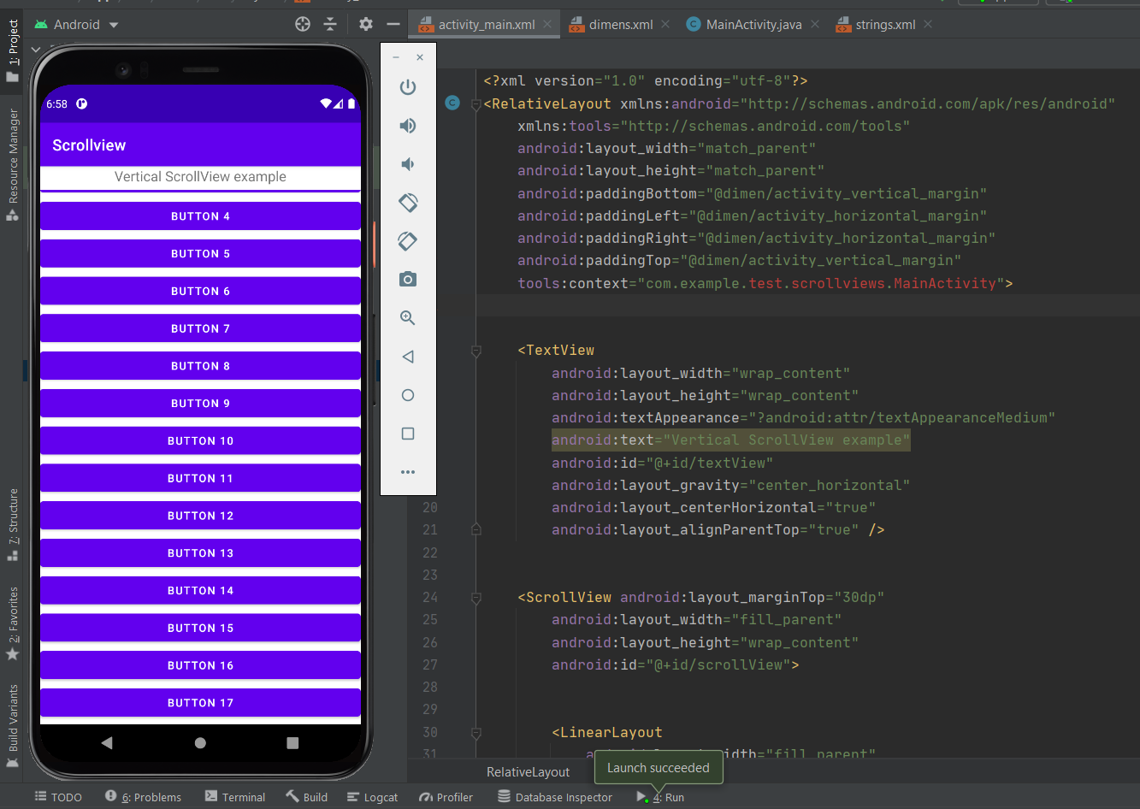

1. **Implement Shared preferences project.**

**Activity_main.xml**

<?xml version="1.0" encoding="utf-8"?>

<RelativeLayout

xmlns:android="http://schemas.android.com/apk/res/android"

xmlns:tools="http://schemas.android.com/tools"

android:layout_width="match_parent"

android:layout_height="match_parent"

tools:context=".MainActivity"

tools:ignore="HardcodedText">

<TextView

android:id="@+id/textview"

android:layout_width="wrap_content"

android:layout_height="wrap_content"

android:layout_centerHorizontal="true"

android:layout_marginTop="32dp"

android:text="Shared Preferences Demo"

android:textColor="@android:color/black"

android:textSize="24sp" />

<EditText

android:id="@+id/edit1"

android:layout_width="match_parent"

android:layout_height="wrap_content"

android:layout_below="@+id/textview"

android:layout_marginStart="16dp"

android:layout_marginTop="8dp"

android:layout_marginEnd="16dp"

android:hint="Enter your Name"

android:padding="10dp" />

<EditText

android:id="@+id/edit2"

android:layout_width="match_parent"

android:layout_height="wrap_content"

android:layout_below="@+id/edit1"

android:layout_marginStart="16dp"

android:layout_marginTop="8dp"

android:layout_marginEnd="16dp"

android:hint="Enter your Age"

android:padding="10dp" />

</RelativeLayout>

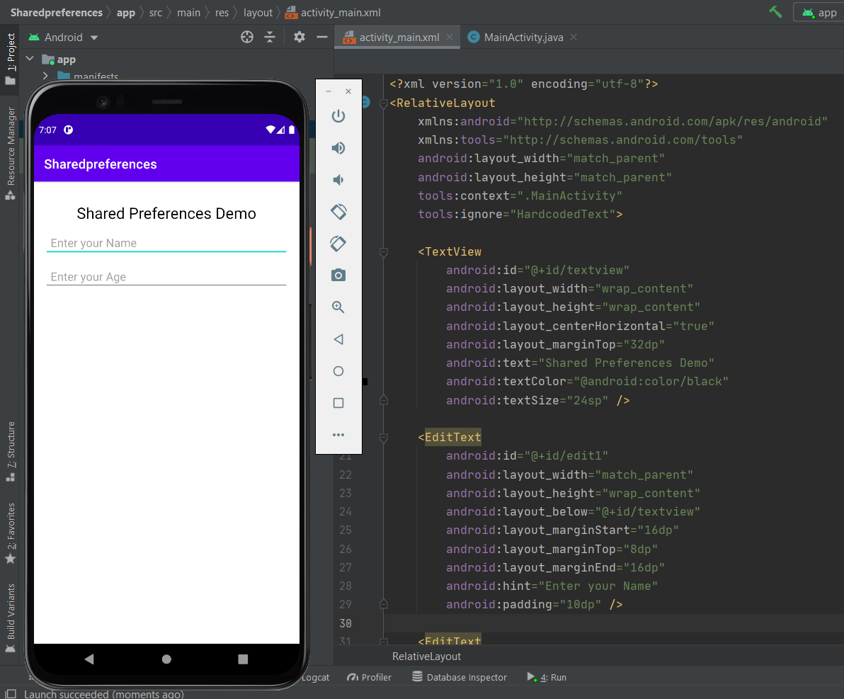

1. **Implement Spinner Project.**

**MainActivity.java**

package com.example.spinner;

import androidx.appcompat.app.AppCompatActivity;

import android.os.Bundle;

import android.view.View;

import android.widget.AdapterView;

import android.widget.ArrayAdapter;

import android.widget.Spinner;

import android.widget.Toast;

public class MainActivity extends AppCompatActivity implements AdapterView.OnItemSelectedListener {

String[] courses = { "C", "Data structures",

"Interview prep", "Algorithms",

"DSA with java", "OS" };

@Override

protected void onCreate(Bundle savedInstanceState) {

super.onCreate(savedInstanceState);

setContentView(R.layout.activity_main);

Spinner spin = (Spinner) findViewById(R.id.spinner);

spin.setOnItemSelectedListener(this);

//Creating the ArrayAdapter instance having the country list

ArrayAdapter aa = new ArrayAdapter(this,android.R.layout.simple_spinner_item,courses);

aa.setDropDownViewResource(android.R.layout.simple_spinner_dropdown_item);

//Setting the ArrayAdapter data on the Spinner

spin.setAdapter(aa);

}

//Performing action onItemSelected and onNothing selected

@Override

public void onItemSelected(AdapterView<?> arg0, View arg1, int position, long id) {

Toast.makeText(getApplicationContext(),courses[position] , Toast.LENGTH_LONG).show();

}

@Override

public void onNothingSelected(AdapterView<?> arg0) {

// TODO Auto-generated method stub

}

}

**Activity_main.xml**

<?xml version="1.0" encoding="utf-8"?>

<androidx.constraintlayout.widget.ConstraintLayout

xmlns:android="http://schemas.android.com/apk/res/android"

xmlns:tools="http://schemas.android.com/tools"

xmlns:app="http://schemas.android.com/apk/res-auto"

android:layout_width="match_parent"

android:layout_height="match_parent"

tools:context=".MainActivity">

<Spinner

android:id="@+id/spinner"

android:layout_height="50dp"

android:layout_width="160dp"

android:layout_marginEnd="10dp"

android:layout_marginStart="10dp"

android:layout_marginBottom="10dp"

android:layout_marginTop="10dp"

app:layout_constraintStart_toStartOf="parent"

app:layout_constraintTop_toTopOf="parent"/>

</androidx.constraintlayout.widget.ConstraintLayout>

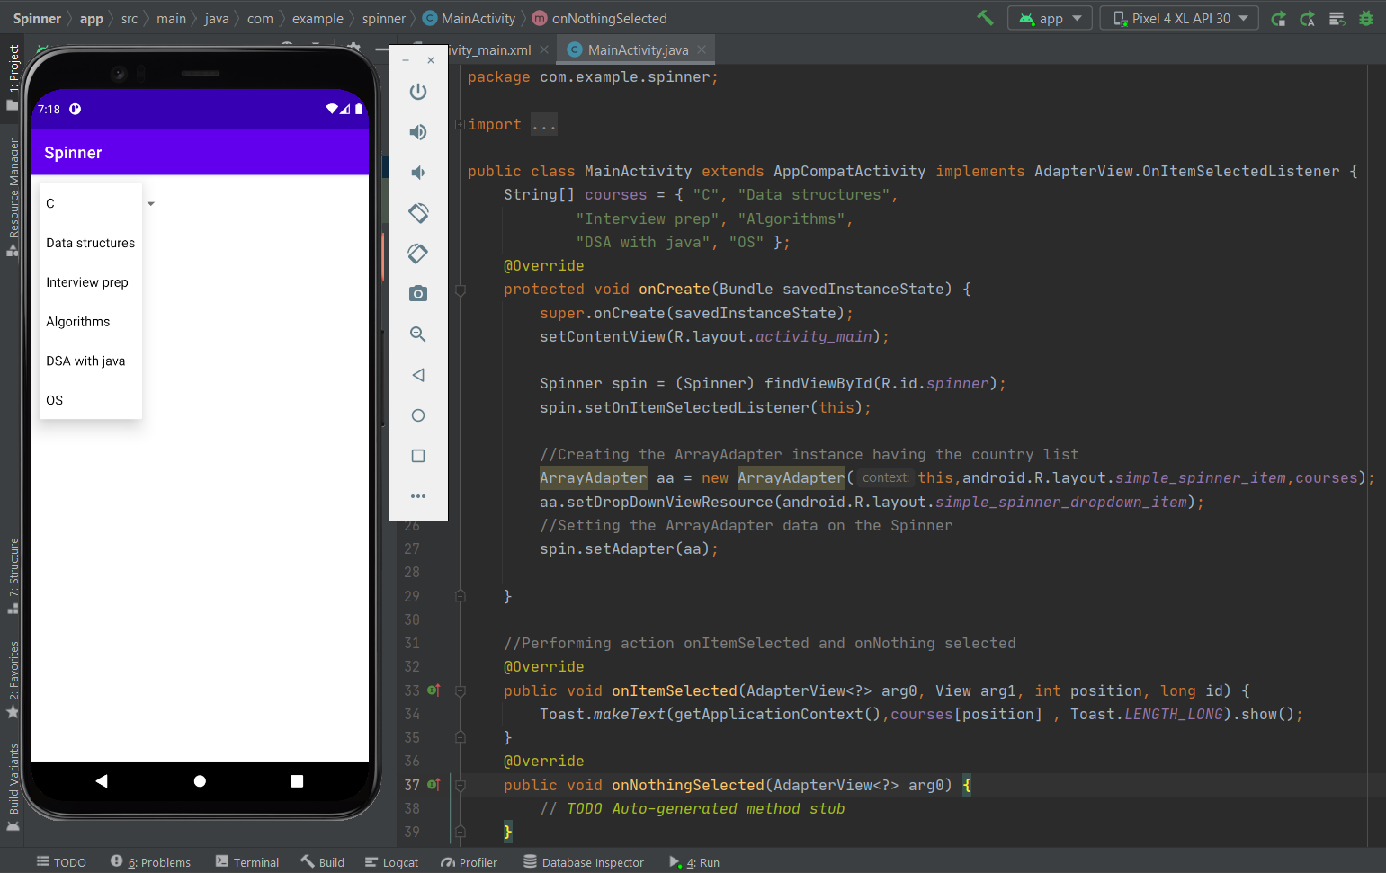

1. **Implement text view button project.**

**Activity_main.xml**

<?xml version="1.0" encoding="utf-8"?>

<androidx.constraintlayout.widget.ConstraintLayout xmlns:android="http://schemas.android.com/apk/res/android"

xmlns:app="http://schemas.android.com/apk/res-auto"

xmlns:tools="http://schemas.android.com/tools"

android:layout_width="match_parent"

android:layout_height="match_parent"

tools:context=".MainActivity">

<TextView

android:id="@+id/textExample"

android:layout_width="200dp"

android:layout_height="100dp"

android:layout_marginTop="149dp"

android:background="@color/design_default_color_error"

android:gravity="center"

android:text="Hello World to the Human"

android:textColor="#FFFFFF"

android:textSize="24sp"

app:layout_constraintEnd_toEndOf="parent"

app:layout_constraintStart_toStartOf="parent"

app:layout_constraintTop_toTopOf="parent" />

<Button

android:id="@+id/button"

android:layout_width="wrap_content"

android:layout_height="wrap_content"

android:layout_marginTop="50dp"

android:text="Button"

app:layout_constraintEnd_toEndOf="parent"

app:layout_constraintHorizontal_bias="0.5"

app:layout_constraintStart_toStartOf="parent"

app:layout_constraintTop_toTopOf="parent" />

<Button

android:id="@+id/domagic"

android:layout_width="250dp"

android:layout_height="250dp"

android:layout_marginTop="50dp"

app:backgroundTint="@color/purple_200"

android:background="@drawable/buttonshape"

android:text="Do Your Magic"

android:textColor="@color/white"

android:textSize="24sp"

app:layout_constraintEnd_toEndOf="parent"

app:layout_constraintStart_toStartOf="parent"

app:layout_constraintTop_toBottomOf="@+id/textExample" />

</androidx.constraintlayout.widget.ConstraintLayout>

**MainActivity.java**

package com.example.textviewbutton;

import androidx.appcompat.app.AppCompatActivity;

import android.graphics.Color;

import android.os.Bundle;

import android.view.View;

import android.widget.Button;

import android.widget.TextView;

public class MainActivity extends AppCompatActivity {

TextView text;

Button button;

@Override

protected void onCreate(Bundle savedInstanceState) {

super.onCreate(savedInstanceState);

setContentView(R.layout.activity_main);

text = findViewById(R.id.textExample);

button = findViewById(R.id.domagic);

text.setTextColor(Color.BLACK);

text.setText("This is an example");

button.setOnClickListener(new View.OnClickListener() {

@Override

public void onClick(View v) {

button.setBackgroundColor(Color.BLACK);

text.setText("I have done my magic");

text.setVisibility(View.INVISIBLE);

button.setVisibility(View.INVISIBLE);

}

});

}

}

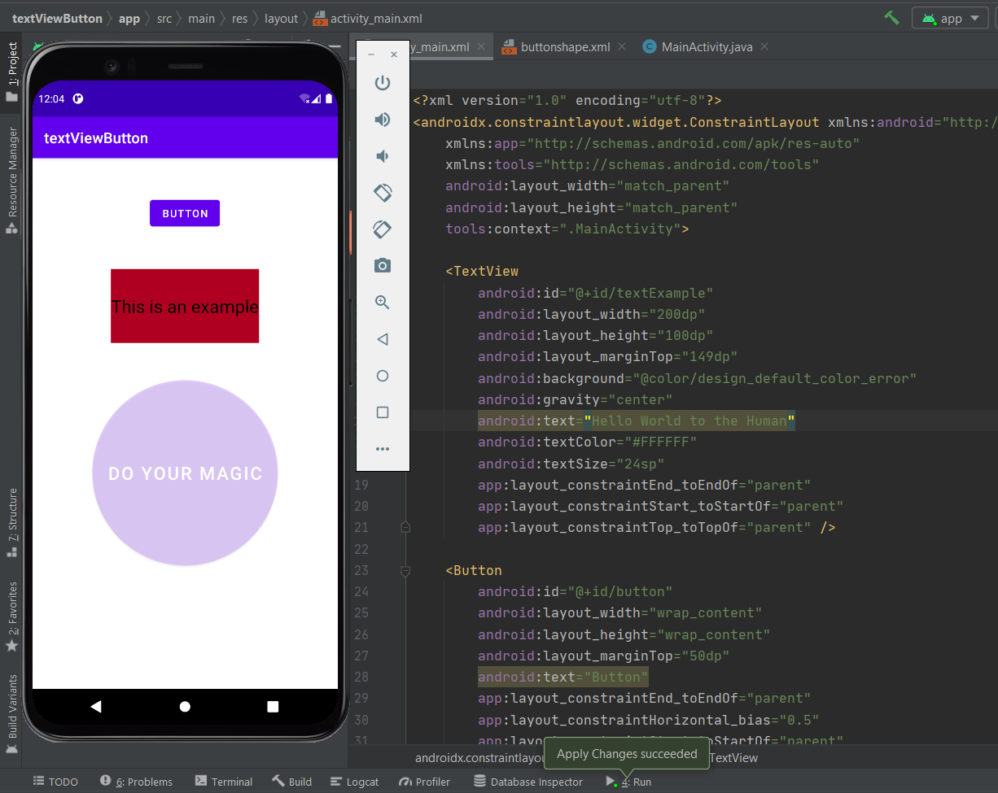

1. **Implement todo list project.**

**Activity_main.xml**

<?xml version="1.0" encoding="utf-8"?>

<LinearLayout xmlns:android="http://schemas.android.com/apk/res/android"

xmlns:app="http://schemas.android.com/apk/res-auto"

xmlns:tools="http://schemas.android.com/tools"

android:layout_width="match_parent"

android:layout_height="match_parent"

android:background="@android:color/holo_blue_bright"

android:orientation="vertical"

tools:context=".MainActivity">

<LinearLayout

android:layout_width="match_parent"

android:layout_height="wrap_content"

android:layout_margin="5dp"

android:orientation="horizontal">

<EditText

android:id="@+id/editText"

android:layout_width="wrap_content"

android:layout_height="wrap_content"

android:layout_weight="4"

android:ems="10"

android:hint=" Add new item"

android:inputType="textPersonName" />

<Button

android:id="@+id/button"

android:layout_width="wrap_content"

android:layout_height="wrap_content"

android:layout_weight="1"

android:text="Add" />

</LinearLayout>

<ListView

android:id="@+id/list"

android:layout_width="match_parent"

android:layout_height="match_parent" />

</LinearLayout>

**MainActivity.java**

package com.example.todolist;

import androidx.appcompat.app.AppCompatActivity;

import android.os.Bundle;

import android.view.View;

import android.widget.ArrayAdapter;

import android.widget.Button;

import android.widget.EditText;

import android.widget.ListView;

import java.util.ArrayList;

public class MainActivity extends AppCompatActivity {

EditText item;

Button add;

ListView listView;

ArrayList<String> itemList = new ArrayList<>();

ArrayAdapter<String> arrayAdapter;

@Override

protected void onCreate(Bundle savedInstanceState) {

super.onCreate(savedInstanceState);

setContentView(R.layout.activity_main);

item = findViewById(R.id.editText);

add = findViewById(R.id.button);

listView = findViewById(R.id.list);

itemList=FileHelper.readData(this);

arrayAdapter = new ArrayAdapter<>(this, android.R.layout.simple_list_item_1,

android.R.id.text1,itemList);

listView.setAdapter(arrayAdapter);

add.setOnClickListener(new View.OnClickListener() {

@Override

public void onClick(View view) {

String itemName = item.getText().toString();

itemList.add(itemName);

item.setText("");

FileHelper.writeData(itemList,getApplicationContext());

arrayAdapter.notifyDataSetChanged();

}

});

}

}

**FileHelper.java**

package com.example.todolist;

import android.content.Context;

import java.io.FileInputStream;

import java.io.FileNotFoundException;

import java.io.FileOutputStream;

import java.io.IOException;

import java.io.ObjectInputStream;

import java.io.ObjectOutputStream;

import java.util.ArrayList;

public class FileHelper {

public static final String FILENAME = "listinfo.dat";

public static void writeData(ArrayList<String> item, Context context)

{

try {

FileOutputStream fos = context.openFileOutput(FILENAME,Context.MODE_PRIVATE);

ObjectOutputStream oas = new ObjectOutputStream(fos);

oas.writeObject(item);

oas.close();

} catch (FileNotFoundException e) {

e.printStackTrace();

} catch (IOException e) {

e.printStackTrace();

}

}

public static ArrayList<String> readData(Context context)

{

ArrayList<String> itemList = null;

try {

FileInputStream fis = context.openFileInput(FILENAME);

ObjectInputStream ois = new ObjectInputStream(fis);

itemList = (ArrayList<String>) ois.readObject();

} catch (FileNotFoundException e) {

itemList = new ArrayList<>();

e.printStackTrace();

} catch (IOException e) {

e.printStackTrace();

} catch (ClassNotFoundException e) {

e.printStackTrace();

}

return itemList;

}

}

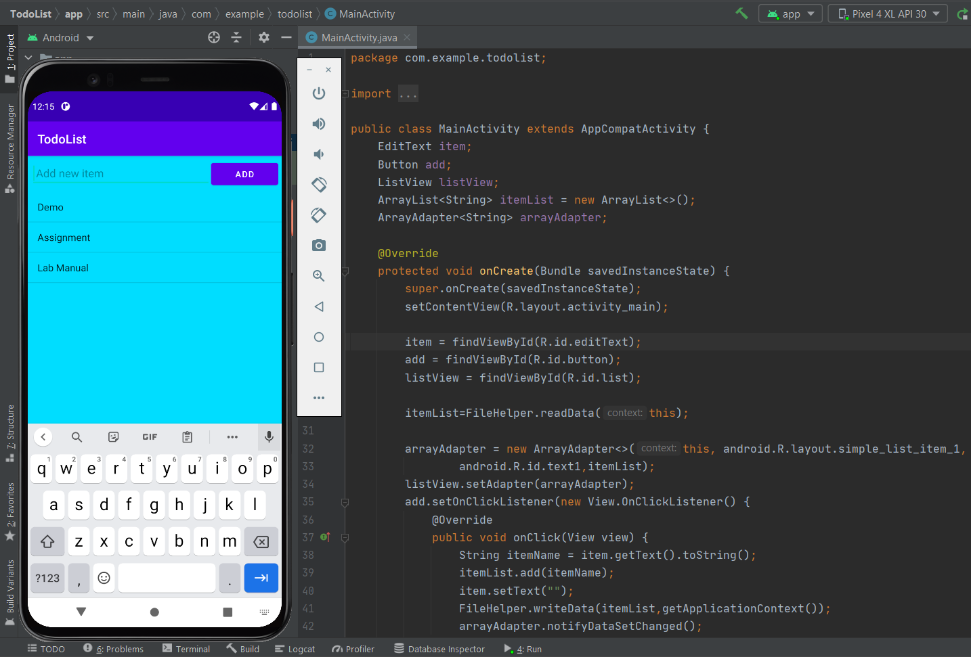

1. **Implement toggle button project.**

**MainActivity.java**

package com.example.togglebutton;

import androidx.appcompat.app.AppCompatActivity;

import android.os.Bundle;

import android.view.View;

import android.widget.CompoundButton;

import android.widget.ImageView;

import android.widget.TextView;

import android.widget.ToggleButton;

public class MainActivity extends AppCompatActivity {

ImageView image;

ToggleButton toggleButton;

TextView result;

@Override

protected void onCreate(Bundle savedInstanceState) {

super.onCreate(savedInstanceState);

setContentView(R.layout.activity_main);

image = findViewById(R.id.imageViewExample);

toggleButton = findViewById(R.id.toggleButtonShow);

result = findViewById(R.id.textViewResult);

toggleButton.setOnCheckedChangeListener(new CompoundButton.OnCheckedChangeListener() {

@Override

public void onCheckedChanged(CompoundButton buttonView, boolean isChecked) {

if (isChecked)

{

image.setVisibility(View.INVISIBLE);

result.setText("Image is hidden");

}

else

{

image.setVisibility(View.VISIBLE);

result.setText("Image is shown");

}

}

});

}

}

**Activity_main.xml**

<?xml version="1.0" encoding="utf-8"?>

<LinearLayout xmlns:android="http://schemas.android.com/apk/res/android"

xmlns:app="http://schemas.android.com/apk/res-auto"

xmlns:tools="http://schemas.android.com/tools"

android:layout_width="match_parent"

android:layout_height="match_parent"

android:background="@android:color/holo_blue_dark"

android:gravity="center_horizontal"

android:orientation="vertical"

tools:context=".MainActivity">

<ImageView

android:id="@+id/imageViewExample"

android:layout_width="300dp"

android:layout_height="200dp"

android:layout_marginTop="10dp"

android:scaleType="fitCenter"

app:srcCompat="@drawable/a" />

<ToggleButton

android:id="@+id/toggleButtonShow"

android:layout_width="wrap_content"

android:layout_height="wrap_content"

android:layout_marginTop="10dp"

android:text="ToggleButton"

android:textOff="Hide Image"

android:textOn="Show Image" />

<TextView

android:id="@+id/textViewResult"

android:layout_width="300dp"

android:layout_height="40dp"

android:layout_marginTop="30dp"

android:background="@color/white"

android:gravity="center"

android:text="What is your gender?"

android:textColor="@color/black"

android:textSize="20sp" />

<Button

android:id="@+id/buttonOk"

android:layout_width="200dp"

android:layout_height="wrap_content"

android:layout_marginTop="30dp"

android:backgroundTint="@color/white"

android:text="OK"

android:textColor="@color/black"

android:textSize="20sp" />

</LinearLayout>

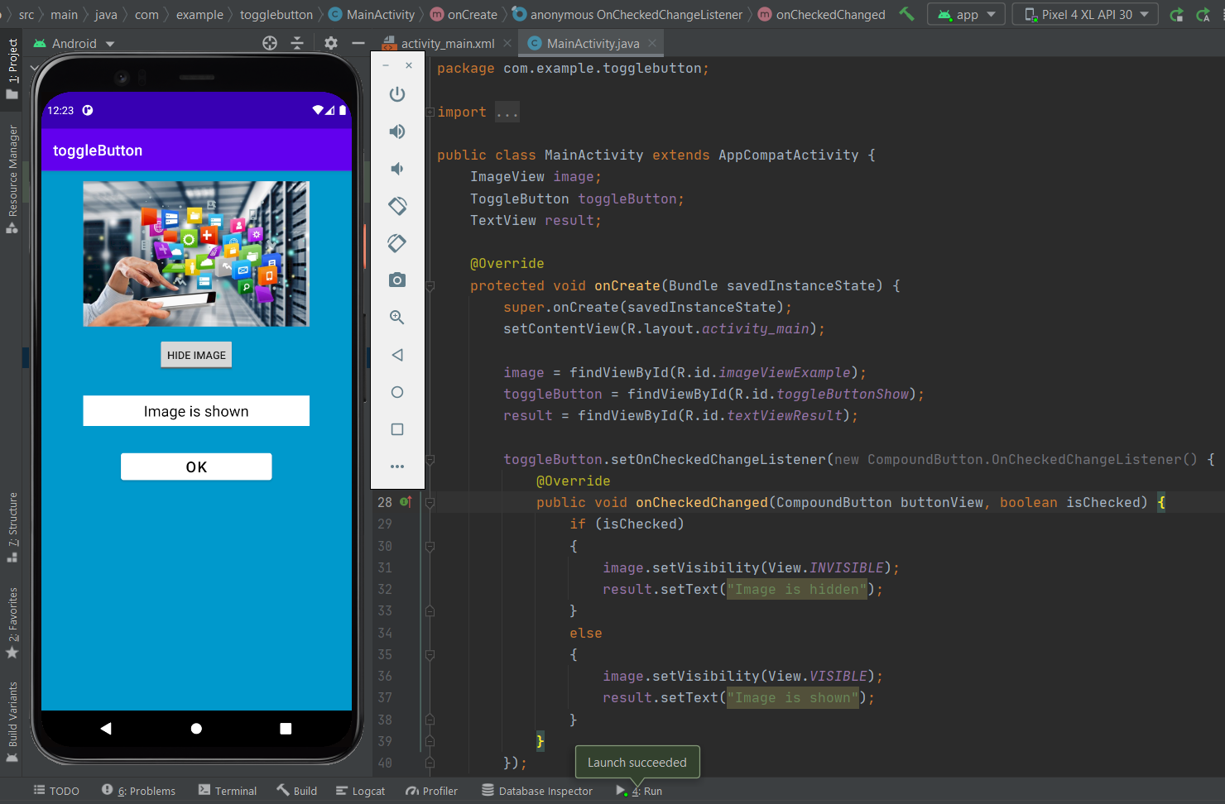

1. **Implement Unit Converter project.**

**Activity_main.xml**

<?xml version="1.0" encoding="utf-8"?>

<androidx.constraintlayout.widget.ConstraintLayout xmlns:android="http://schemas.android.com/apk/res/android"

xmlns:app="http://schemas.android.com/apk/res-auto"

xmlns:tools="http://schemas.android.com/tools"

android:layout_width="match_parent"

android:layout_height="match_parent"

tools:context=".MainActivity">

<EditText

android:id="@+id/editText"

android:layout_width="wrap_content"

android:layout_height="wrap_content"

android:ems="10"

android:inputType="number"

app:layout_constraintBottom_toBottomOf="parent"

app:layout_constraintEnd_toEndOf="parent"

app:layout_constraintHorizontal_bias="0.497"

app:layout_constraintStart_toStartOf="parent"

app:layout_constraintTop_toTopOf="parent"

app:layout_constraintVertical_bias="0.249" />

<Button

android:id="@+id/button"

android:layout_width="wrap_content"

android:layout_height="wrap_content"

android:text="Submit"

app:layout_constraintBottom_toBottomOf="parent"

app:layout_constraintEnd_toEndOf="parent"

app:layout_constraintHorizontal_bias="0.476"

app:layout_constraintStart_toStartOf="parent"

app:layout_constraintTop_toBottomOf="@+id/editText"

app:layout_constraintVertical_bias="0.334" />

<TextView

android:id="@+id/textView"

android:layout_width="289dp"

android:layout_height="41dp"

app:layout_constraintBottom_toTopOf="@+id/button"

app:layout_constraintEnd_toEndOf="parent"

app:layout_constraintStart_toStartOf="parent"

app:layout_constraintTop_toBottomOf="@+id/editText" />

<TextView

android:id="@+id/textView2"

android:layout_width="219dp"

android:layout_height="68dp"

android:text="Enter The KG Value"

android:textSize="20sp"

app:layout_constraintBottom_toTopOf="@+id/editText"

app:layout_constraintEnd_toEndOf="parent"

app:layout_constraintHorizontal_bias="0.583"

app:layout_constraintStart_toStartOf="parent"

app:layout_constraintTop_toTopOf="parent"

app:layout_constraintVertical_bias="0.446" />

</androidx.constraintlayout.widget.ConstraintLayout>

**MainActivity.java**

package com.example.unitconverter;

import androidx.appcompat.app.AppCompatActivity;

import android.os.Bundle;

import android.view.View;

import android.widget.Button;

import android.widget.EditText;

import android.widget.TextView;

import android.widget.Toast;

public class MainActivity extends AppCompatActivity {

private Button button;

private TextView textView;

private EditText editText;

@Override

protected void onCreate(Bundle savedInstanceState) {

super.onCreate(savedInstanceState);

setContentView(R.layout.activity_main);

button = findViewById(R.id.button);

textView = findViewById(R.id.textView);

editText = findViewById(R.id.editText);

button.setOnClickListener(new View.OnClickListener() {

@Override

public void onClick(View view) {

Toast.makeText(MainActivity.this, "WE Got the answer", Toast.LENGTH_SHORT).show();

String s = editText.getText().toString();

int kg = Integer.parseInt(s);

double pound = 2.205 * kg ;

textView.setText("The Corresponding value in pound is" + pound);

}

});

}

}

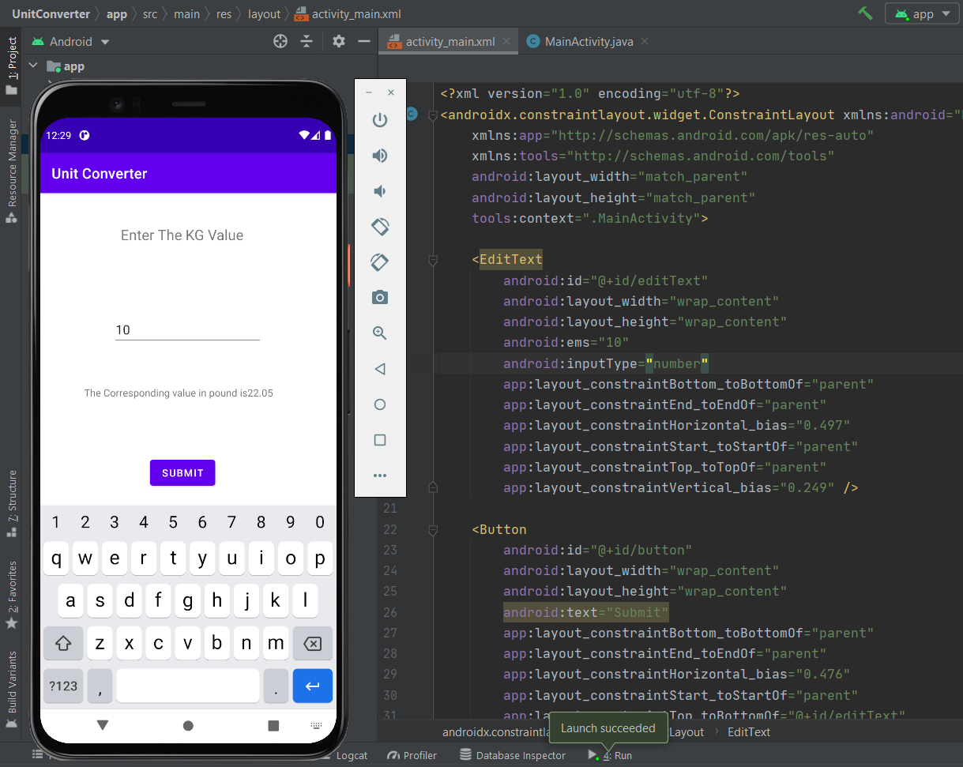

1. **Implement web view project.**

**MainActivity.java**

package com.example.webview;

import androidx.appcompat.app.AppCompatActivity;

import android.os.Bundle;

import android.webkit.WebView;

import android.webkit.WebViewClient;

public class MainActivity extends AppCompatActivity {

WebView webView;

@Override

protected void onCreate(Bundle savedInstanceState) {

super.onCreate(savedInstanceState);

setContentView(R.layout.activity_main);

webView = findViewById(R.id.web);

webView.setWebViewClient(new WebViewClient());

webView.loadUrl("https://www.google.com/");

}

@Override

public void onBackPressed() {

if(webView.canGoBack())

{

webView.goBack();

}

else {

super.onBackPressed();

}

}

}

**Activity_main.xml**

<?xml version="1.0" encoding="utf-8"?>

<androidx.constraintlayout.widget.ConstraintLayout xmlns:android="http://schemas.android.com/apk/res/android"

xmlns:app="http://schemas.android.com/apk/res-auto"

xmlns:tools="http://schemas.android.com/tools"

android:layout_width="match_parent"

android:layout_height="match_parent"

tools:context=".MainActivity">

<WebView

android:id="@+id/web"

android:layout_width="match_parent"

android:layout_height="match_parent" />

</androidx.constraintlayout.widget.ConstraintLayout>

